Collaboration is the word!
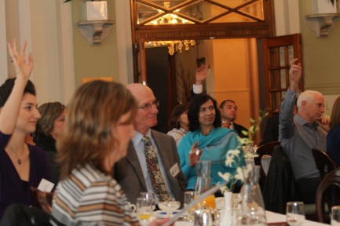
In one of a series of collaborative sessions, PMI Sydney Chapter held a breakfast event on Wednesday 5th September at the Castlereagh Boutique Hotel. More than fifty members enjoyed presentations from Ambition, Paxus, UXC Consulting and Peak Performance where they got career advice, hints and tips on personal branding , training opportunities and project management capabilities assessments. The feedback from our members was extremely positive.
This is one of a series of strategic initiatives to foster collaboration, provide further opportunities and create awareness within the various professional organisations, industries and markets.
We are currently planning a return for our extremely popular speed learning event. Further details will be provided on PMI Sydney Chapter Website soon. Watch this space.

